NS  The distance from Earth to the Sun is  92,900,000 miles. What is this number  in scientific notation? | NS  Between which two whole numbers is $\sqrt{66}$ located on a number line?  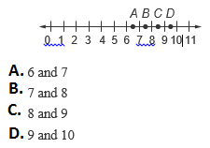
SP  A store had daily sales of $15,696,  $23,400, $19,080, $18,000, $23,400, $17,604, and $15,228 last week. Which data measure would make the sales last week appear the most profitable?  F. mean  G. median  H. mode  I. range | SP  Laurie wants to buy a new sweater that costs $45. The sweater is on sale for 25% off and  6.75% sales tax will be applied to the purchase. What will be the total cost of the sweater?
F  Beth’s monthly charge for Internet access c is represented by the function c = 12 + 2.50h, where h represents the number of hours of usage during a month. What is the total charge for a month in which Beth used the Internet for 9 hours?  A. $39.95  B. $34.50  C. $27.00  D. $22.50 | F  What is the domain of the relation  {(–1, 4), (4, 6), (–3, –7), (2, –1)}?
G  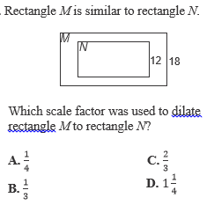 | G  